ORGANIC CHEMISTRY

PAST EXAM QUESTIONS

Section 1: Functional Groups, Naming, Properties, Reactions 2

Section 2: Amines, Amides, Amino Acids, Proteins 33

WACE 2016 Sample Q18 and Q19 refer to the compounds shown below.

WACE 2016 Sample Q18:
Which one of the following lists places the compounds in their correct class?
i ii iii iv
- Ester Aldehyde Ketone Carboxylic acid
- Carboxylic acid Ketone Aldehyde Ester
- Ketone Carboxylic acid Ester Aldehyde
- Ester Carboxylic acid Ketone Aldehyde

WACE 2016 Sample Q19:
Which of the compounds can be prepared by oxidation of 1-propanol, CH₃CH₂CH₂OH?
- i only
- i and ii
- ii and iii
- ii and iv

WACE 2016 Sample Q20:
Consider the following substances.
- BaSO₄ ii. CH₃CH₂CH₂CH₂OH
iii. CH₃CH₂COCH₃ iv. H₂NCH₂COOH
Which one of the following lists the substances in order of decreasing solubility in water?
- i iv ii iii
- i iii ii iv
- iv ii iii i
- ii iv iii i
WACE 2016 Sample Q17:
Which one of the following will react with acidified potassium dichromate solution to give a ketone?
- CH₃CH₂CH₂OH
- CH₃CH₂CHO
- CH₃CH(OH)CH₃
- (CH₃)₃COH

WACE 2015 Q3:
An aqueous solution of ethanoic (acetic) acid can react with:
- magnesium to produce a solution of magnesium ethanoate and hydrogen gas
- solid potassium carbonate to produce a solution of potassium ethanoate, carbon dioxide gas and water
- sodium hydroxide solution to produce a solution of sodium ethanoate and water
- acidified propan-1-ol to produce ethyl propanoate and water
Which of the above statements is true?
- I and IV only
- II and IV only
- I, II and III only
- I, II, III and IV

WACE 2015 Q14:
Which one of the following lists the solubilities of butane (C₄H₁₀), butan-2-ol (CH₃CH(OH)CH₂CH₃) and butanone (CH₃COCH₂CH₃) in water, from most soluble to least soluble?
- butan-2-ol butanone butane
- butan-2-ol butane butanone
- butanone butan-2-ol butane
- butane butanone butan-2-ol

WACE 2015 Q22:
Which one of the following lists the substances in order of increasing (from lowest to highest) boiling point?
- CH₃CH₃ CH₃CH₂OH CH₃CHO CH₃COOH
- CH₃CH₃ CH₃CHO CH₃CH₂OH CH₃COOH
- CH₃CH₂OH CH₃CH₃ CH₃COOH CH₃CHO
- CH₃COOH CH₃CHO CH₃CH₂OH CH₃CH₃
WACE 2015 Q24:
What is the name of the organic compound produced when 2-fluoropent-1-ene reacts with fluorine gas?
- 2-fluoropentane
- 1,2-difluoropentane
- 1,1,2-trifluoropentane
- 1,2,2-trifluoropentane

WACE 2015 Q25:
Between which of the following pairs of substances can hydrogen bonding occur?
- CH₃COCH₃ and CH₃NH₂
- CH₃CHO and HF
- C₂H₆ and CH₃OH
- CH₃F and H₂O
- I, II and III only
- I, II and IV only
- I, III and IV only
- II only

WACE 2014 Q20:
Which of the following compounds has the highest boiling point?
- 1-chloropropane
- propan-1-ol
- propanal
- methylpropane

WACE 2014 Q21:
How many isomers are there with the molecular formula C₂H₂Br₂?
- 2
trans-1,2-dibromoethene
cis-1,2-dibromoethene
1,1-dibromoethene
- 3
- 4
- 5

WACE 2014 Q23:
In the following diagram what are the molecular formula of substances X and Y likely to be?
X Y
- C₄H₈ C₄H₆
- C₄H₈ C₄H₁₀
- C₄H₁₀ C₄H₈
- C₄H₆ C₄H₈

WACE 2014 Q24:
Which one of the following is the IUPAC name for the compound below?
- 2,3-dichloro-trans-but-2-ene
- 2,3-dichloro-cis-but-2-ene
- 1,2-dichloro-trans-but-2-ene
- 1,2-dichloro-cis-but-2-ene

TEE 2009 Q25:
Which one of the following compounds has an empirical formula different to the other three?
- ethanal CH₃CHO C₂H₄O C₂H₄O
- propyl methanoate HCOOCH₂CH₂CH₃ C₄H₈O₂ C₂H₄O
- ethanol CH₃CH₂OH C₂H₆O C₂H₃O
- butanoic acid CH₃CH₂CH₂COOH C₄H₈O₂ C₂H₄O

WACE 2014 Q25:
Question 25 refers to the structures shown below.
Which one of the following gives their increasing order of solubility in water?
- IV < II < III < I
- IV < II < I < III
- III < I < IV < II
- I < III < II < IV

WACE 2013 Q25:
Consider the following statements about the compound shown below.
- It will decolourise iodine water
- If 1 mol of the compound is mixed with 2 mol of chlorine, all of the chlorine can react
- Its systematic name is cis-pent-2-ene
- It is soluble in hexane
Which of the statements are correct?
- I and III only
- II and IV only
- II, III and IV only
- I, II, III and IV

WACE 2012 Q21:
Which one of the following is a substitution reaction?
- CH₃CH₂CH₂CH₂Br + Br₂ → CH₃CH₂CH₂CHBr₂ + HBr
- CH₃CH₂CHCH₂ + Br₂ → CH₃CH₂CHBrCH₂Br
- CH₃CH₂CH₂COOH + CH₃OH → CH₃CH₂CH₂COOCH₃ + H₂O
- CH₃CH₂CHCH₂ + H₂ → CH₃CH₂CH₂CH₃

VCE 2014 Q19:
What is the systematic name for the product of the reaction above?
- 2-methylpentanoic acid
- 4-methylpentanoic acid
- 2-methylbutanoic acid
- 3-methylbutanoic acid

VCE 2013 Q9:
The systematic IUPAC name for the molecule shown above is
- ethyl ethanoate
- ethyl propanoate
- propyl ethanoate
- methyl propanoate

WACE 2013 Q22, 23 and 24 refer to Compounds I to IV below.
WACE 2013 Q22:
Which one of the following lists the functional groups for Compounds I to IV correctly?
I II III IV
- Aldehyde Ketone Ester Carboxylic acid
- Carboxylic acid Aldehyde Ester Ketone
- Aldehyde Ketone Alcohol Carboxylic acid
- Aldehyde Ketone Carboxylic acid Ester

WACE 2013 Q23:
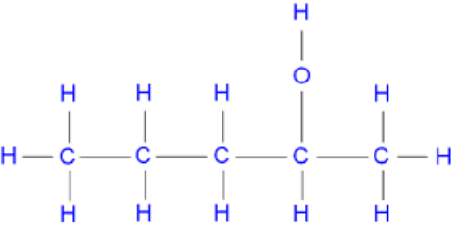
Which one of the alcohols below can be oxidised to produce Compound II?
- CH₃CH₂CH₂CH₂CH₂OH
- CH₃CH₂CH₂CHOHCH₃
- CH₃CH₂CHOHCH₂CH₃
- CH₃C(OH)(CH₃)CH₂CH₃

WACE 2013 Q24:
Which one of Compounds I to IV will react with an alcohol in the presence of an acid?
- I
- II
- III (alcohol + carboxylic acid → ester)
- IV
Use the information below to answer WACE 2010 Q23 and Q24.

WACE 2010 Q23:
Which one of the following is the formula for the product B from the reaction of A with hydrogen chloride?
- CH₃CHCHCH₂Cℓ
- CH₃CHCℓCHCℓCH₃
- CH₃CH₂CHCℓCH₃
- CH₃CH₂CH₂CH₂Cℓ

WACE 2010 Q24:
Which one of the following is the formula for the product C from the reaction of A with chlorine?
- CH₃CHCHCH₂Cℓ
- CH₃CHCℓCHCℓCH₃
- CH₃CH₂CHCℓCH₃
- CH₂CℓCHCHCH₂Cℓ

VCE 2015 Q13:
What is the name of the product formed when chlorine, Cℓ₂, reacts with but-1-ene?
- 1,2-dichlorobutane
- 1,4-dichlorobutane
- 2,2-dichlorobutane
- 2,3-dichlorobutane

WACE 2012 Q25:
Which one of the following will react with acidified potassium dichromate to give a ketone?
- CH₃CH₂CH₂OH
- CH₃CH₂CHO
- CH₃CH(OH)CH₃
- (CH₃)₃COH
WACE 2012 Questions 22 to 24 refer to the following structures:

WACE 2012 Q22:
Which of these compounds are geometric isomers?
- (i) and (ii) (ii) is not an isomer of (i). It is the same molecule as (i)
- (i), (ii) and (iii)
- (i) and (iv)
- (iii) and (iv)

WACE 2012 Q23:
How many moles of oxygen will be consumed in the complete combustion of 1 mole of compound (i)?
- 1 mol C₅H₁₀ + 15/2 O₂ → 5 CO₂ + 5 H₂O
- 3.5 mol
- 5 mol
- 7.5 mol

WACE 2012 Q24:
Which one of the following is the product from the reaction of bromine with Compound (iii)?
- CH₃CH₂CBr(CH₃)CH₂Br
- CH₃CH₂BrCH(CH₃)CH₃
- CH₃CH₂BrCH(CH₃)CH₂Br
- CH₃CH₂CH(CH₃)CH₂Br
VCE 2013 Q10:
The systematic IUPAC name for the product of the above chemical reaction is
- 1-chlorobutane
- 2-chlorobutane
- 3-chlorobutane
- 4-chlorobutane

WACE 2016 Sample Q29:
Examine the two compounds below. Compound 1 is the naturally-occurring flavouring agent vanillin. Compound 2 is the local anaesthetic procaine. Name the functional groups circled in these two compounds.
(4 marks)

TEE 2005 Q13:
Complete the following table: (6 marks)
IUPAC Name | Structural Formula
5-chloro-3-methylpentanal | CH₃ O  | ||  Cl-CH₂-CH₂-CH-CH₂-C-H
butanoic acid | CH₃CH₂CH₂COOH
butan-2-ol
4-chloropentan-2-one | O Cl  || |  CH₃-C-CH₂-CH-CH₃
propan-1-amine | CH₃-CH₂-CH₂-NH₂
4-chloro-3-methylpentanoic acid

TEE 2007 Q4 / TEE 2009 Q10:
Name and draw the structural formula for each of the following. (6 marks)
Description | Structural Formula | Name
A tertiary alcohol containing four carbon atoms per molecule | CH₃  |  CH₃-C-CH₃  |  OH | 2-methylpropan-2-ol
A primary amine containing nine hydrogen atoms | CH₃CH₂CH₂NH₂  OR  CH₃CHCH₃  |  NH₂ | propan-1-amine  propan-2-amine
The product of the oxidation of  pentan-2-ol | O  ||  CH₃-C-CH₂-CH₂-CH₃ | pentan-2-one

TEE 2005 Q1:
Write equations for any reactions that occur in the following procedure. If no reaction occurs write ‘no reaction’. Describe in full what you would observe.

- Butane gas is burnt in air (3 marks)

2 C₄H₁₀ + 13 O₂ 8 CO₂ + 10 H₂O (1)
Yellow/orange flame produced. Heat released. Colourless, odourless gas produced. (at least 2 observations needed – 2 marks)

TEE 2007 Q7:
Below is the structural formula of a chlorofluorocarbon.
Draw and name the structure of TWO other isomers of this compound. (4 marks)
Structural Formula | Name
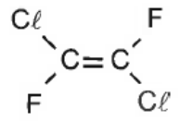 | trans-1,2-dichloro-1,2-difluoroethene
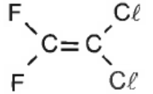 | 1,1-dichloro-2,2-difluoroethene

WACE 2015 Q36:
Aspirin is one of the most popular and readily available pain-relieving drugs. The structure of aspirin is given below:
A
B
Aspirin contains two functional groups.

- On the diagram of aspirin above, circle the two functional groups. Label them A and B.
- Name each functional group. (2 marks)
Functional group A: Carboxylic acid
Functional group B: Ester
TEE 2006 Q13:
For each of the following reactions draw the structural formula of the organic product. (4 marks)
Reaction | Structural Formula
Acidified butanoic acid is added to methanol and heated | O  ||  CH₃CH₂CH₂C-O-CH₃
Hydrogen gas is bubbled through but-2-ene | CH₃CH₂CH₂CH₃
Acidified potassium dichromate is added to ethanol | O  CH₃COOH OR ||  CH₃C-H
Chlorine gas is added to excess propane and exposed to UV light | CH₃CH-CH₃  | OR CH₃CH₂CH₂Cl  Cl

TEE 2005 Q12:
A chemist adds acetic acid (ethanoic acid) to separate beakers containing ethanol and sulfuric acid, and acidified potassium permanganate. Complete the following table. (3 marks)
Reactants | Observations
Acetic acid + ethanol and sulfuric acid | Fruity odour produced (and vineger smell disappears)
Acetic acid + acidified potassium permanganate | No reaction and no visible change

Write a balanced equation for any reactions that occur.
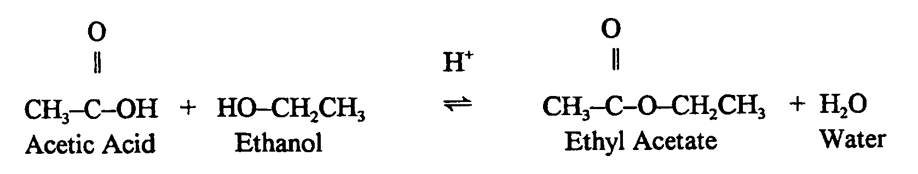
WACE 2015 Q34:
Each organic compound has a molecular formula containing four carbon atoms, one oxygen atom and a number of hydrogen atoms. The observations made are summarised in the following table.
Unknown organic compound | Reagent added
 | acidified  sodium permanganate solution | acidified  propanoic acid
1 | no observable change | fruity smell
2 | purple solution decolourises | non observable change
3 | non observable change | non observable change
- Complete the table below, identifying the:
- functional group responsible for the observations made
- organic compound, by drawing its structural formula or giving its name. (6 marks)
Unknown organic compound | Functional group | Structural formula or name  of the organic compound
1 | alcohol
2 | aldehyde
3 | ketone

In part (a) candidates identified correctly that Compound 1 was an alcohol but few drew the structure of a tertiary alcohol as required.
Many candidates represented the functional group using the general formula (e.g. R-OH, RCHO) rather than identifying the specific functional group.
- Draw the structural formula, showing all atoms of the organic product of the reactions of Compound 1 and Compound 2.

- Organic Compound 1 with the acidified propanoic acid

- Organic Compound 2 with the acidified sodium permanganate solution

(Depends on answer given for Compound 2)
For part (b)(i) and part (b)(ii) more than 12% and 20% of candidates respectively did not attempt this question indicating that many found this question challenging. These questions provided the opportunity to distinguish the more capable candidates. Most candidates who attempted the question identified the products correctly, gaining at least part marks.
WACE 2016 Sample Q28:
The active ingredient in aspirin tablets (acetylsalicylic acid) has the structure shown below:
When acetylsalicylic acid is placed in water, some of it dissolves and ionises to form its conjugate base.
- Write the equation for the ionisation of acetylsalicylic acid in the space below, and identify the conjugate acid and base pairs in the reaction. Connect each acid-base pair with a line, and label the conjugate acid in the pair ‘A’, and the conjugate base ‘B’. (3 marks)
Most candidates were not able to rewrite correctly the complete structure of the aspirin. Candidates should be discouraged from converting structures to molecular formulas as too many candidates did this incorrectly. A significant number of candidates also did not follow the instructions to label both acid-base pairs and connect them both with lines.
- Acetylsalicylic acid is a weak acid, and only partly ionises in water. It is poorly soluble in water, and far less soluble than a related compound, acetic acid (CH₃COOH). Explain why the water solubility of molecular acetylsalicylic acid is less than that of CH₃COOH. (3 marks)

- For a substance to dissolve, the attraction solute-solvent attractions must be strong enough to overcome the solute-solute attraction and solvent-solvent attraction
- A large portion of the acetylsalicylic acid is non-polar and can only form weak dispersion forces with water. Only a small proportion of the molecule can form hydrogen bonds with water
- A larger portion of the acetic acid is able to form hydrogen bonds with water, leading to increased solubility.
Generally candidates showed a poor understanding of the relationship between intermolecular forces and solubility.

WACE 2016 Sample Q33:
Consider the following reactions and complete the tables that follow.
- An excess of 2-butanol is oxidised by acidified Na₂Cr₂O₇ solution. (3 marks)

Observations | solution turns from orange to green
Structural formula of
organic product

(show all atoms)
Name of  organic product | butanone

- Butanoic acid reacts with methanol in the presence of H₂SO₄ solution. (3 marks)

Observations | fruity odour is produced
Structural formula of
organic product

(show all atoms)
Name of  organic product | methylbutanone

This question was not particularly well done. Candidates must be encouraged to describe their observations in as much detail as possible – e.g. a fruity/sweet smell should be described as just that, rather than simply a ‘strong smell’. A detailed observation is evidence of a candidate’s full understanding of a process, and more general descriptions of observations cannot be rewarded.
The majority of candidates gave the correct structural formulae and organic product names for these questions, although ‘butone’ featured commonly in place of ‘butanone’. Some focus should perhaps be given to correct naming of ketones.
WACE 2014 Q29:
Ethanol, CH₃CH₂OH, and hexane, C₆H₁₄ are two common industrial solvents.

- Identify the polarity of molecules that are soluble in each of these solvents. (2 marks)

 | Polarity of molecules/substances that are soluble in solvent
Ethanol | (circle one only)
 | Polar | Non-polar
Hexane | (circle one only)
 | Polar | Non-polar

- Explain the interactions between solute and solvent particles in solutions of these two solvents. (3 marks)

For substances to dissolve there solute-solvent force of attraction needs to be similar strength or stronger than solute-solute interactions and solvent-solvent interactions. (1 mark)

Ethanol dissolves polar solutes by forming hydrogen bonds or dipole-dipole forces between the solute and solvent particles. (1 mark)

Hexane dissolves non-polar solutes by forming dispersion forces between solute and solvent particles. (1 mark)

For part (a)(ii) many candidates tried to explain using the terms polar/non-polar. The question clearly asks candidates to explain the interactions between solute and solvent particles. Many candidates simply stated that ethanol has H bonding and hexane dispersion forces rather than describing the force of attraction each forms with solutes.

- Ethanol and water are often mixed together in the manufacture of a range of substances. The following data was recorded during one production process.

Substance | Volume (mL)
water | 50
ethanol | 50
mixture of water and ethanol | 96

The ‘loss’ of 4 mL on mixing water with ethanol implies strong interactions between the water and ethanol molecules. Describe these interactions and explain the origin of their strength. (4 marks)

Both ethanol and water have hydrogen bonding in the pure substances. (1 mark)

When dissolved, water and ethanol molecules form hydrogen bonds with each other. (1 mark)

Hydrogen bonding is possible because these substances have H atoms covalently bonded to O. There is a large difference in electronegativity between O and H, resulting in a very polar bond. (1 mark)

As a result, the H atom from the OH group is δ+ and is strongly attracted to the lone pairs of electrons from O atoms of neighbouring molecules. (1 mark)
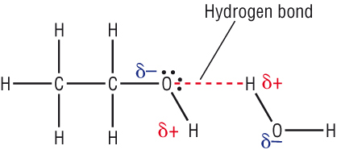

Many candidates failed to mention the origin of the interactions.
WACE 2014 Q33:
- Methanoic acid, HCOOH, may be produced by oxidation of an alcohol with acidified potassium permanganate, MnO₄⁻, solution.

Write the oxidation and reduction half-equations and the final redox equation for this reaction.
(5 marks)

(2)
(1)
(2)
State symbols not required. If oxidation and reduction are reverse award a max of 4 marks.
Balancing the final equation requires cancelling of H⁺ and H₂O. Award 1 mark if not simplified.
Candidates should be encouraged to write the condensed structural formula (e.g. CH₃OH) rather than the molecular formula (e.g. CH₄O).

- Methanoic acid reacts with ethanol in the presence of sulfuric acid to produce a sweet smelling compound.

Write the balanced equation for the reaction of methanoic acid with ethanol. (2 marks)

HCOOH + CH₃CH₂OH HCOOCH₂CH₃ + H₂O (2) Deduct 1 if water is missing

Although candidates may have been able to correctly draw the structure of the ester in part (c), they were unable to write its formula in part (b).

- Draw the structural formula for the sweet smelling compound and give its IUPAC name. Show all H atoms in the structure. (2 marks)

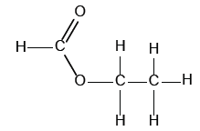 (1) | Name: Ethyl methanoate (1) _________________________________

WACE 2014 Q34:
Alcohols can be classified as primary, secondary or tertiary.
Complete the table below by drawing the structure for a primary alcohol, a secondary alcohol and a tertiary alcohol, each with the molecular formula C₅H₁₂O. Show all H atoms in your structures.
Give the IUPAC names for the primary and secondary alcohols you have drawn. (5 marks)

 | Structure | Name
Primary  alcohol |  | Possible answers:  - pentan-1-ol  - 2-methylbutan-1-ol  - 2,2,-dimethylpropan-1-ol
Secondary  alcohol |  | Possible answers:  - pentan-2-ol  - pentan-3-ol  - 3-methylbutan-2-ol
Tertiary  alcohol |  | Name not required.

This question was well done, however candidates were penalized for not giving a 5-carbon structure although they may well have been able to draw a primary, secondary or tertiary alcohol.

A few candidates omitted the ‘1’ in pentan-1-ol.

WACE 2016 Sample Q40:
- Glycerol (IUPAC name: propane-1,2,3-triol) can be used an anti-freeze due to its high water solubility. Explain, with the aid of a diagram, why glycerol has high solubility in water. (5 marks)

- Glycerol and water both have hydrogen bonding as the predominant types of intermolecular force (IMF) in the pure substance

- Glycerol is able to form hydrogen bonds with water molecules

- The hydrogen bonds formed between glycerol and water molecules are similar in strength to the H bonds within each individual substance. The similarity in strength between the two interactions leads to glycerol being able to dissolve.

- Diagram

Most candidates were unable to adequately describe the processes occurring during dissolution, and were equally unable to draw the diagram that suitably illustrates the forces established during dissolution.

The relative strength of the solute-solvent interactions and solute-solute, solvent-solvent interactions during dissolution should be highlighted to candidates.

WACE 2013 Q27:
- Mixtures of propan-2-ol and propanone can be separated by distillation due to their different boiling points. Explain why these compounds have such different boiling points even though they have very similar molar masses. (3 marks)

 | 2-propanol | propanone
Boiling point (°C) | 82 | 56
Molar mass (g mol⁻¹) | 60 | 58

Both molecular has the similar molar masses, therefore have similar strength dispersion forces. (1)
The main type of intermolecular force between propan-2-ol molecules is hydrogen bonding, whereas the main type of intermolecular force between propanone molecules is dipole-dipole forces (1)
The boiling point of propan-2-ol is higher than the boiling point of propanone because hydrogen bonding is stronger than dipole-dipole forces (1)

Very few commented on the similar strength of dispersion forces.
Although many were able to identify that the predominant IMF in propan-2-ol is H-bonding, they failed to recognise dipole-dipole interactions in propanone and hence were awarded 0.

WACE 2013 Q36:
Draw the structure in the box provided and name the organic product(s) for each of the following reactions. Include all H atoms in your structures.
- CH₃CH₂CHCHCH₃ + Br₂ (2 marks)

(1) | Name: 2,3-dibromopentane

WACE 2013 Q35:
A white solid is analysed and found to have the empirical formula CHO and a molar mass of 116 g mol⁻¹.
- Determine the molecular formula of the compound. Justify your answer. (2 marks)

(1)

Molecular formula is C₄H₄O₄ (1)

- Two tests were conducted on the white solid, as shown in the table below. Complete the table by drawing a possible functional group that is consistent with the finding of each of the tests. (2 marks)

Test | Observation | Possible functional group
Water solubility | 788 g L⁻¹ | O  ||  R-OH OR R-C-OH
Add to bromine water | Bromine water decolourises rapidly | \ /  C=C  / \

Many students wrote the name of the functional group in (b) instead of drawing the structure.

- A further 2.32 g sample of the white solid was analysed and shown to release 0.0400 mol of H⁺ ions. Use this information and your answers to (a) and (b) to determine the structural formula of the white solid, and draw it in the box below. Show all atoms in your structure. (3 marks)

n(sample) = m / M = 2.32 / 116 = 0.0200 mol (1)
Must release 2 H⁺ per molecule, therefore dicarboxylic acid (1)

Possible structure(s): note – could be cis or trans
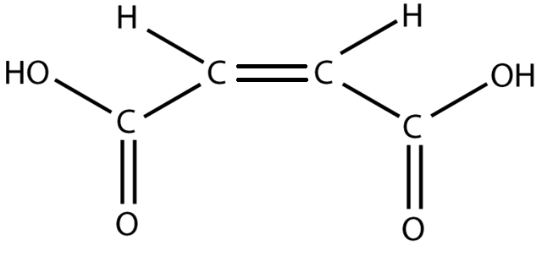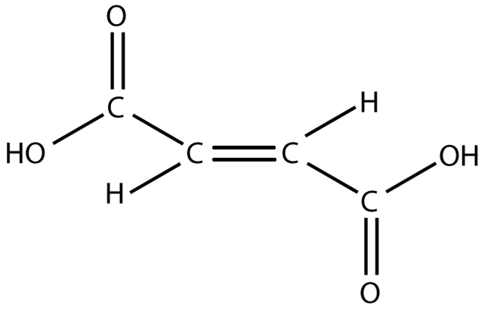

Many candidates had difficulty understanding the relevance of the calculation in © but were able to obtain part-marks with a correct drawing.

WACE 2012 Q27:
Examine the data in the table below. Use your knowledge of intermolecular forces to explain the differences in boiling points of the three compounds listed in the table.
The difference in boiling points is due to differences in strength of intermolecular forces (1).
Both butanol and butanoic acid have hydrogen bonding as their predominant intermolecular force (1)
Butanal has dipole-dipole forces, and these are weaker than hydrogen bonding therefore lowest boiling point (1)
Butanoic acid has a higher boiling point than butanol because the COOH group has the capacity to form multiple hydrogen bonds (/dimers are formed) (1)

Candidates did not recognsie the different functional groups and the IMF associated with them as being the more significant bonding to explain the trends. The most common incorrect answers focused exclusively on dispersion forces.
Most candidates, also, did not explicitly link the relative strength of the IMF to the boiling points and so could not be awarded full marks.

WACE 2011 Q30:
Complete the table below by giving a brief description of a chemical test that could be used to distinguish between the substances listed. List the observations relating to the test for each of Substance 1 and Substance 2. (6 marks)
Substances to be distinguish |  | Description of chemical test | Observation with Substance 1 | Observation with Substance 2
Substance 1 | Substance 2
butan-2-ol  (2º alc) | 2-methylpropan-2-ol  (3º alc) | Add acidified KMnO₄  OR  Add acidified K₂Cr₂O₇ | Purple colourless  Orange Green | No visible reaction
methanol  (1º alc) | methanal  (aldehyde) | Add acidified ethanoic acid  (or other carbox. acid) | Fruity smell develops | No fruity smell

This was perhaps the most difficult question in Section Two and was not well done. A common error was to not include acidified permanganate or dichromate in distinguishing between the two alcohols.

WACE 2011 Q32:
- Draw the structure for, and write the name of, any five straight chain isomers for the compounds with the molecular formula C₅H₁₀. Show all atoms in the structures. (10 marks)
Note: There are more than 5 possible answers
Structure | Name
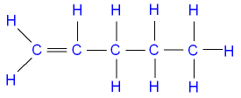 | pent-1-ene
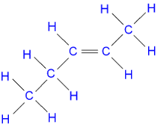 | trans-pent-2-ene
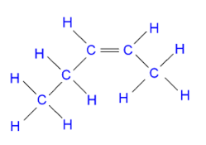 | cis-pent-2-ene
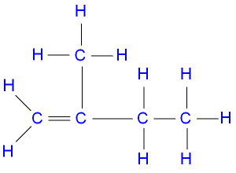 | 2-methylbut-1-ene
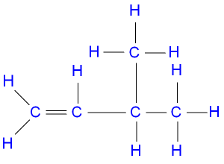 | 3-methylbut-1-ene
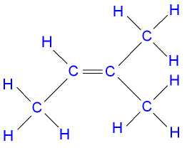 | 2-methylbut-2-ene
A number of candidates presented cyclic isomers in part (a). Candidates should be reminded to read the question carefully and thoroughly. “Straight chain isomers” precludes the possibility of having cyclic isomers.

- An organic compound is known to be an ester. Its molar mass is 74 g mol⁻¹.

  - Draw the structural formula for the compound. Show all atoms in the structure. (1 mark)
  - Write the name for the compound you have drawn. (1 mark)
  - What is the IUPAC name for a carboxylic acid that has the same molecular formula as the ester above? (1 mark)

- 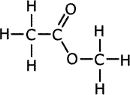 OR 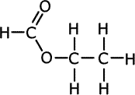
- ^ methyl ethnoate ^ ethyl methanoate
- Propanoic acid

WACE 2012 Q42:
- Give the structure of, and name, the primary amine with 2 carbon atoms. Show all atoms in your structure and draw your structure in the box below. (2 marks)

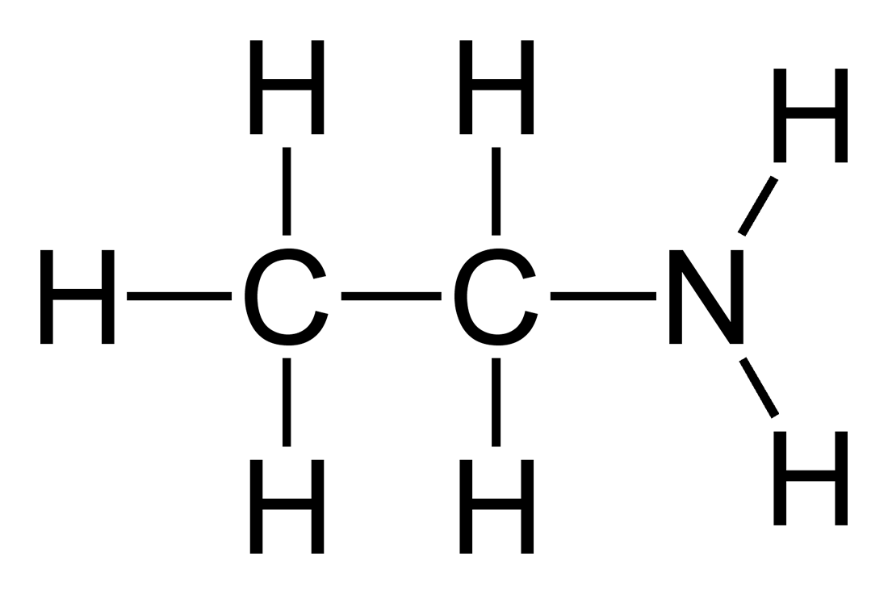 ethanamine
WACE 2010 Q29:
Benzoic acid is found in many berries and some other fruits, and is used as a food preservative. The structure of benzoic acid is shown below. In an aqueous environment, benzoic acid ionises and exists in equilibrium with the benzoate ion.
- Write the equation for the reaction between benzoic acid and water. (1 mark)

- Draw the structure (either benzoic acid or the benzoate ion) that would predominate in the acidic environment of the stomach. (1 mark)

- The ease with which a substance is excreted from the body is determined in part by its solubility in water. Is benzoic acid more or less miscible with water than acetic (ethanoic acid), and hence more or less readily excreted from the body? Explain. (3 marks)

Benzene has low solubility in water compared to acetic acid and therefore is less readily excreted. The benzoic acid molecule contains a COOH group and a benzene ring. Water can form hydrogen bonds with the COOH group, but the benzene ring is non-polar and has very little interaction with water molecules. This lowers the solubility of benzoic acid. This contrasts to acetic acid, which has a COOH group (miscible with water) and a proportionately small alkyl group (less miscible with water). Overall solubility of acetic acid will be greater than that of benzoic acid.

1 mark each for the following points:
- Carboxylic acid group forming H bonds with water
- Benzene ring non-polar, little attraction to water
- Balance of polar and non-polar groups makes benzoic acid less soluble in water than acetic acid

WACE 2016 Sample Q21:
Which one of the following compounds is an α-amino acid?

VCE 2013 Q11:
Australian jellyfish venom is a mixture of proteins for which there is no antivenom. Jellyfish stings are painful, can leave scars and, in some circumstances, can cause death.
Some commercially available remedies disrupt ionic interactions between the side chains on amino acid residues. These products most likely disrupt the protein’s
- primary structure only
- secondary structure only
- tertiary structure only
- primary, secondary and tertiary structures

WACE 2016 Sample Q24:
Proteins that show a high degree of similarity in their primary structure in the Protein Data Bank are most likely to have
- similar function
- identical tertiary structure
- been isolated from the same species
- the same amino acid composition
VCE 2015 Q14:
Which one of the following is not true of protein denaturation?
- It could result from a temperature change
- It may be caused by a pH change
- It alters the primary structure
- It results in a change in the shape of the protein
WACE 2014 Q22:
Which one of the following is not a primary amine?
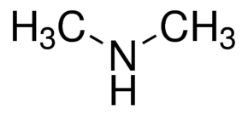
- CH₃NH₂
- CH₃CH(NH₂)CH₃
Primary amine has NH₂ group
- CH₃NHCH₃
- CH₃CH₂CH₂NH₂

WACE 2016 Sample Q32:
Below are the structures for the amino acid valine under different pH conditions. In the spaces provided, give an approximate pH range (acidic, basic or neutral) under which each valine structure would exist.
(3 marks)
WACE 2015 Q39:
Amino acids are biologically-important organic compounds containing both amine (-NH₂) and carboxylic acid (-COOH) functional groups.
An important amino acid is 2-aminopropanoic acid; usually known as alanine. It is a component in more than a thousand different proteins, found in an array of foods and can be produced within the body.

- Alanine is an alpha (α) amino acid. State the structural feature of alanine that allows it to be classified as an alpha (α) amino acid. (1 mark)

The -NH₂ group and the -COOH group must be attached to the same carbon atom

Many candidates stated that the two functional groups were attached to a ‘terminal’ carbon or the same ‘terminal’ carbon. This is incorrect as the carbon in COOH would be the ‘terminal’ carbon. While candidates had an idea of what was required, they were unable to express themselves clearly using appropriate terms.
- Use the following information to demonstrate that the molecular formula of alanine is the same as its empirical formula.

When 1.86 g of alanine was vaporized at 550.0 °C and 50.0 kPa pressure, it occupied a volume of 2.86 L. (4 marks)

A large number of candidates did not acknowledge that the formula for the structure given in the question was actually an empirical formula. Too many were simply relating the molecular mass from the calculation to the molecular mass from the drawn structure.

Many candidates performed two calculations to arrive at correct numerical answers but then did not make a linking statement to demonstrate they understood clearly what they had done.
To consider the effect of having both an amine and a carboxylic acid functional group on the same molecule, amino acids can be compared with other organic compounds that have either:
- two amine functional groups on the same molecule (these compounds are called diamines)
or
- two carboxylic acid functional groups on the same molecule (these compounds are called dicarboxylic acids)
Amino acids have significantly higher melting points than diamines and dicarboxylic acids of similar mass and structure. This is illustrated in the table below.
Compound type | Example | Molar mass  g mol⁻¹ | Melting point  °C
diamine | hexane-1,1-diamine | 116.2 | 39
dicarboxylic acid | methylpropanedioic acid | 118.09 | 184
amino acid | 2-amino-3-methylbutanoic acid (valine) | 117.15 | 298

- Explain why amino acids form crystalline solids and have significantly higher melting points than other organic molecules of similar mass and structure. Refer to the information provided in the table on page 34 and include a labelled diagram using the amino acid valine to illustrate your answer.
(5 marks)

This part was not well done. More than 12% of candidates did not attempt this question. Many candidates were unaware of the ionic nature of amino acids in the crystalline solid. Many candidates spent significant time discussing reasons for the difference in the melting points of diamines and dicarboxylic acid which was not required by the question.
This higher order question was designed to provide candidates with the opportunity to demonstrate their crticial reasoning skill. Only the most capable candidates scored on this question.
WACE 2016 Sample Q31:
Examine the structure below that represents a segment of the primary structure of insulin to answer the questions that follow.
- Circle all the peptide linkages (functional groups that link the monomers) represented in the above structure. (1 mark)

- Draw the molecular structure of the three α-amino acids that form this segment of insulin. (3 marks)

- The active form of insulin is made up of two polypeptide chains that contain five alpha helices. State the type of interactions that stabilize these secondary structures and the functional groups involved. (2 marks)
Type of interaction | Functional groups
hydrogen bonding | carbonyl and amide groups

VCE 2015 Q6:
After a murder had been committed, a forensic chemist obtained crime scene blood samples and immediately placed them in two sterile containers labelled Sample I and Sample II.
- The chemist discovered that Sample I contained a particular protein, which was then analysed to reveal the following sequence of amino acid residues.
-ser-gly-tyr-

  - Referring to the data book, draw the structure of this sequence of amino acid residues and circle one amide link/peptide bond in your drawing. (3 marks)

This question proved difficult for some students. The peptide group was often incorrectly shown, quite often with an O atom linked between C and N, and often the peptide group was either not or incorrectly circled/highlighted.
In a number of responses bonds were not left open at both ends, which is a requirement when representing part of the protein chain as shown in the -set-gly-tyr- sequence.
Other errors included incorrect representation of the benzene ring when showing the tyrosine structure and selecting tryptophan rather than tyrosine as ‘tyr’.

  - The protein was hydrolysed in the presence of a suitable enzyme and the amino acid glycine was isolated. The glycine sample was then dissolved in a 0.1 mol L⁻¹ solution of sodium hydroxide.

Draw the structure of glycine in this solution. (1 mark)

Students should be aware that in an alkaline solution, amino acids are deprotonated; the -COOH group is converted to -COO⁻
WACE 2013 Q34:
- Draw the structure of an α-amino acid with a chemical formula of C₂H₅NO₂. (1 mark)

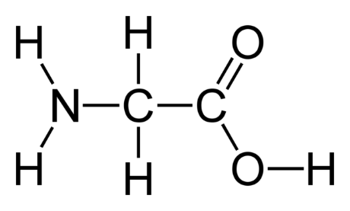 (1) -- Also accept zwitterion form

- The structure for the α-amino acid alanine is given below.

Give the structure for alanine under acidic, neutral and basic conditions by completing the table below. (3 marks)

pH | Structure of alanine
acidic
neutral
basic

In part (b), some candidates transposed the acidic and basic structures. Many were unable to draw these structures. Most candidates draw the neutral structure as the one given in the question and not the zwitterion representation.
- When crystallised from a neutral solution, alanine exists as a white crystalline solid. The solid has a melting point of 258 °C. This contrasts with a melting point of -47 °C for 2-methylpropanoic acid (molar mass 87 g mol⁻¹), a molecule of similar size to alanine. With reference to the appropriate structure in (b), explain why alanine has such a high melting point. (4 marks)

In (c), most candidates did not identify the ionic nature of an amino acid despite the crystalline hint and hence scored 0. Most responses were in terms of hydrogen bonding which attracted no marks. Candidates generally scored either zero or nearly full marks for this question.
VCE 2014 Q7:
Amino acids can be classified according to the nature of their size chains (Z groups). These may be polar, non-polar, acidic or basic.
The table below provides examples of different categories of side chains at a pH of 7.
Name of amino acid | Structure of side chain of pH 7
alanine (Ala) | -CH₃
asparagine (Asn) | -CH₂-CO-NH₂
aspartic acid (Asp) | -CH₂COO⁻
cysteine (Cys) | -CH-SH
lysine (Lys) | -CH₂-CH₂-CH₂-CH₂-NH₃⁺
serine (Ser) | -CH₂OH

- The tertiary structure of proteins is a result of the bonding interactions between side chains of amino acid residues.

Use the information provided in the table above to:

  - Identify the amino acid that is involved in the formation of disulfide bonds (sulfur bridges).
(1 mark)
cysteine

  - Give an example of two amino acid side chains that may form hydrogen bonds between each other. (1 mark)
Asparagine and serine

  - Give an example of amino acid side chains that may form ionic bonds (salt bridges) between each other. (1 mark)
Aspartic acid and lysine

  - Identify the type of bonding that exists between the side chains of two alanine residues.
(1 mark)
Dispersion force attraction

Overall students did not perform well on this question. Most students struggled to identify the groups on the given side chain structures that could form hydrogen bonds (-OH and -NH₂), or that could form ionic bonds (-COO⁻ and -NH₃⁺).
Some students responded with covalent bonding for part (iv), however the side chains are non-polar methyl groups
WACE 2016 Sample Q36:
The diagram below represents a segment of protein, showing the types of interactions that can occur between amino acid side chains to form the tertiary structure.
- Identify these types of interactions, labelled A, B, C and D, by completing the table below. (4 marks)

Label | Type of interaction
A | dispersion forces
B | ionic bond
C | covalent bond OR disulfide bond
D | hydrogen bond

- State what is meant by the ‘tertiary structure’ of a protein. (1 mark)

The tertiary structure is a protein’s overall 3-dimensional shape
VCE 2013 Q3:
Spider webs are very strong and elastic. Spider web silk is a protein that mainly consists of glycine and alanine residues.
- Assuming that these amino acid residues alternate in a spider web, draw a section of the spider web protein that contains at less three amino acid residues. (2 marks)
(or)
- What is the name of the bond between each amino acid residue? (1 mark)
Peptide bond OR amine bond OR covalent bond

Glycine forms an ion at pH of 6 that has both a positive and negative charge.
- Draw the structure of a glycine ion at a pH of less than 4. (1 mark)
Common errors included showing the structure of the zwitterion or a deprotonated carboxyl group. A significant number of students who had identified the correct species then used the incorrect (+) charge location.

Students should be able to draw the structures of the zwitterion, protonated (low pH) and deprotonated (high pH) forms of amino acids.

- Describe the bonds that contribute to the spiral secondary structure of this protein. (2 marks)

Hydrogen bonding between the H atom from one peptide group and the O atom from another peptide group in the same polymer chain. (1 mark for ‘hydrogen bond’, 1 mark for identifying where)
There was evidence of significant confusion between secondary and tertiary structures of a protein.

The key part of this question was the described on bonds that contribute to the spiral secondary structure of the protein. This required more than simply identifying the bond type. Students also had to identify the atoms between which it occurs – H and O on different peptide groups in the protein chain.

